Experiential Learning Application 4-Chapter 6
Name
Institutional Affiliation

Experiential Learning Application 3-Chapter 5
Introduction and problem statement
The role of heart rate in cardiovascular disease and morbidity has for along time been suspected. The work of Perret-Guillaume (2009) noted that heart rate is indeed a risk factor in cardiovascular disease. According to WHO (2017) cardiovascular disease (CVDs) are the number one (leading) cause of death globally. Investigating the correlates of heart rate is therefore of important concern to healthcare profession. Proper prediction of heart rate can therefore help in mitigating the impact of CVDs on the society.
This paper used the SEMMA data mining platform to analyze and conclude on the best model for predicting an individual’s heart rate. The resulting model can then be used to program and design a heart rate prediction app.
Sample
The sample was explored in SAS Enterprise Miner by first including an import node as shown below;
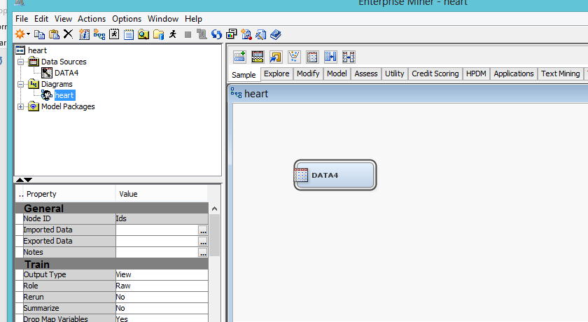
The result of the import node analysis included the input and target variables, as well as the level of the variables as shown below;
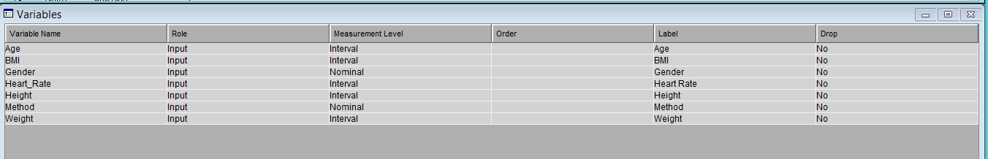
Data partition
In data mining, one of the methods or strategies for the assessment of quality of model generalization is data partitioning of the source data (Abdolell et al , 2002). In the process a portion of the dataset is dedicated to training, evaluation and testing. The data partition node was used for this purpose and the outcome was as follows;
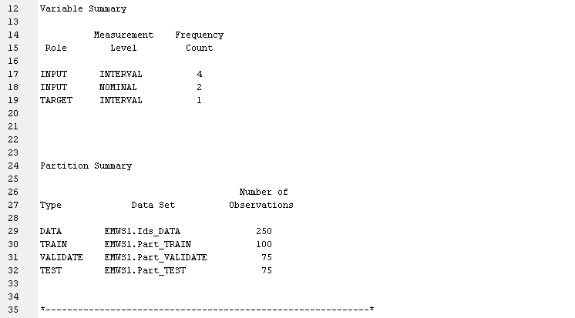
Explore
The explore stage is a critical one in data mining using SAS Enterprise Miner. In this section or state, a stat explore node as well as two others (graph explore and multiplot nodes) were used. The summary of the statistics, graph, missing data and outliers were found as follows;
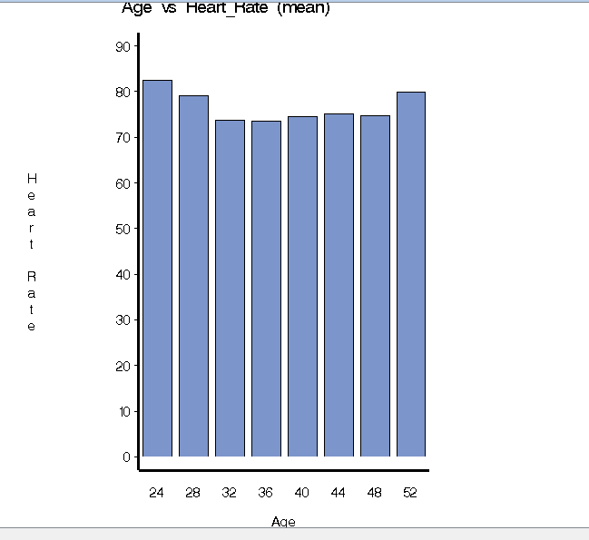
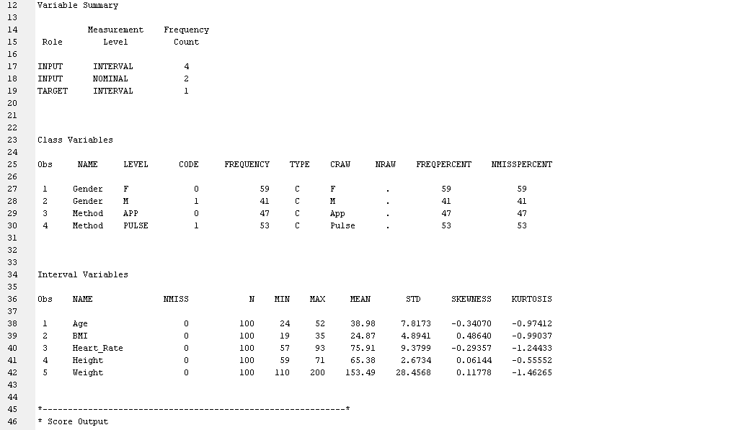

Modify
The modify stage is another critical stage in the data mining process using the SAS Enterprise Miner framework. The result of the IMPUTE node inclusion was meant to fill missing values in order to minimize errors associated with missing values. The impute node was implemented using an algorithm for filling missing values. The result of data imputation was found as follows;
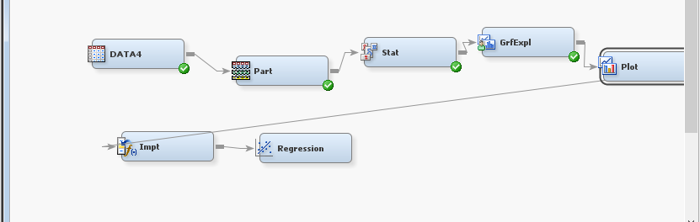

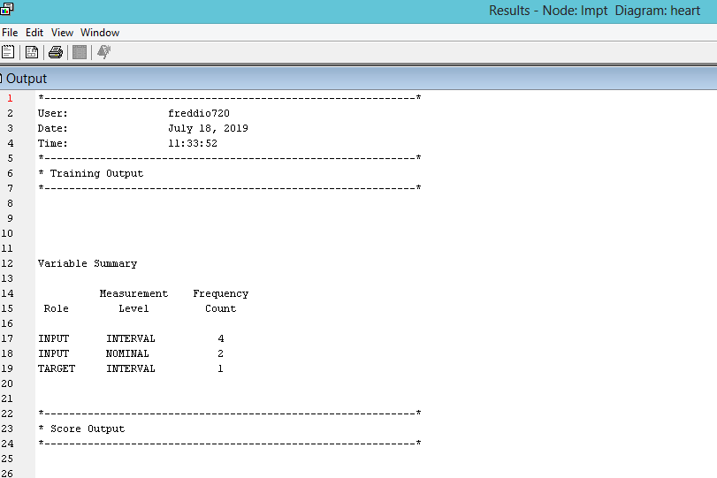
Model
Modelling is the most important state in data mining process. In this case, regression model using backward selection process son the basis of the Schwartz Bayesian Criterion was used. The result of the analysis was as follows;
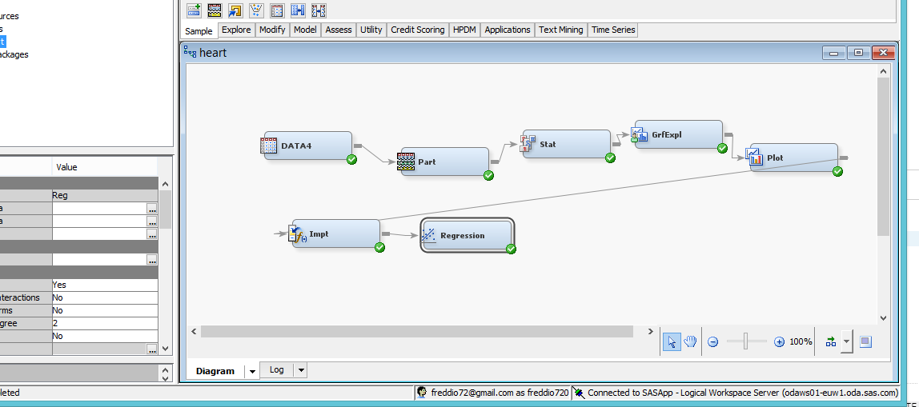

Backward selection regression
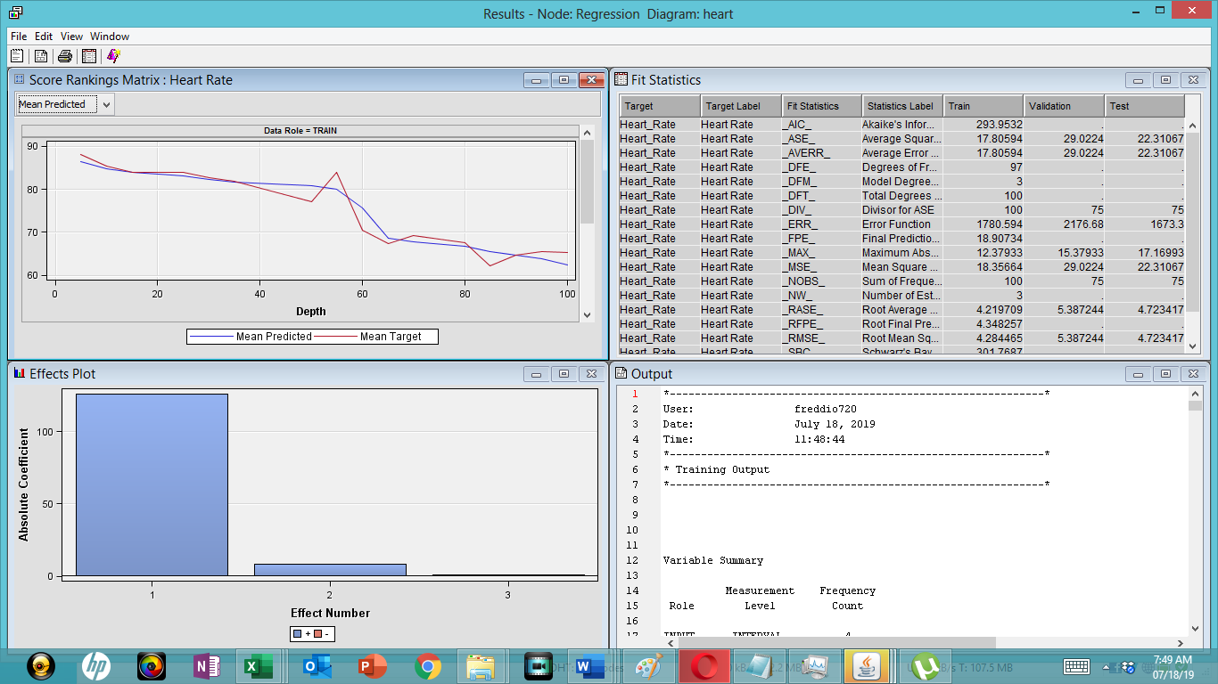

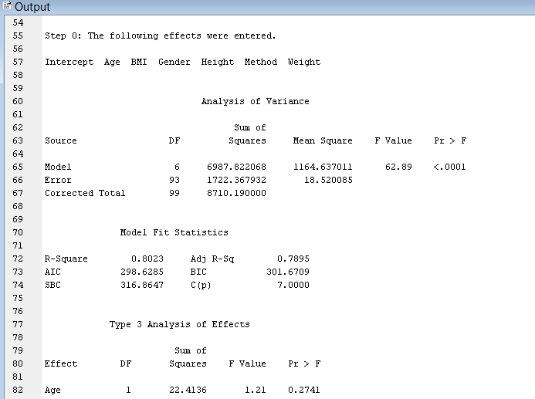

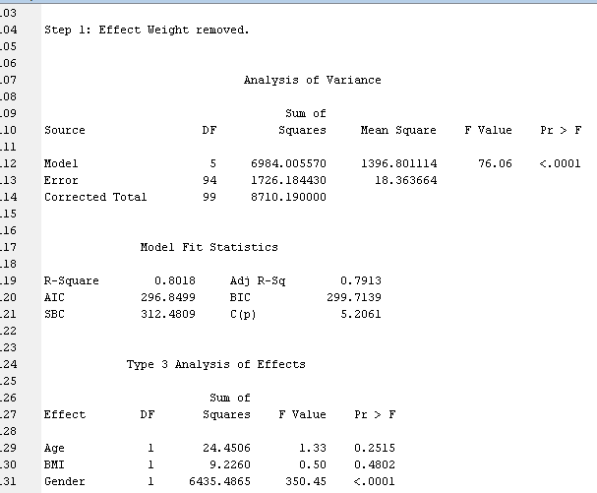
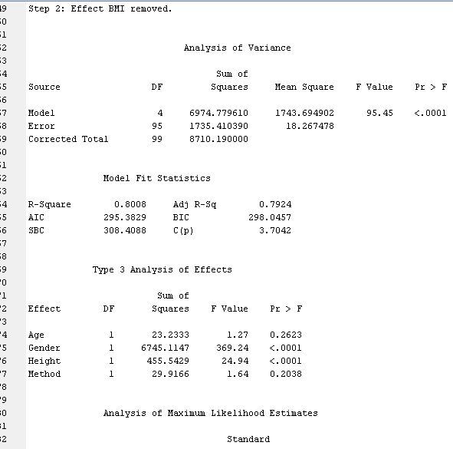

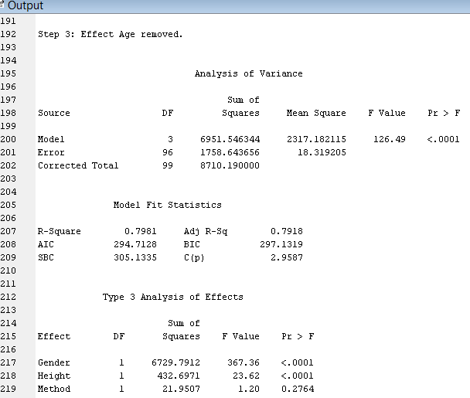
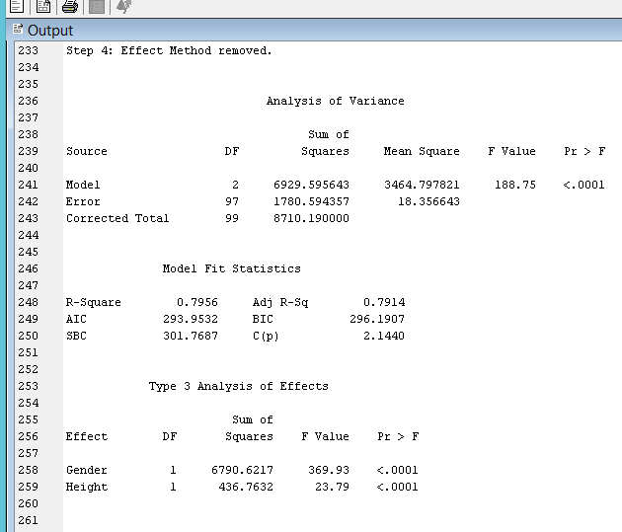
Selected model
The selected model only comprised of gender and height. The model’s coefficient of determination (R²) was found to be 0.7914. The implication is that gender and height when used in model can predict 79.14% variation in heart rate.
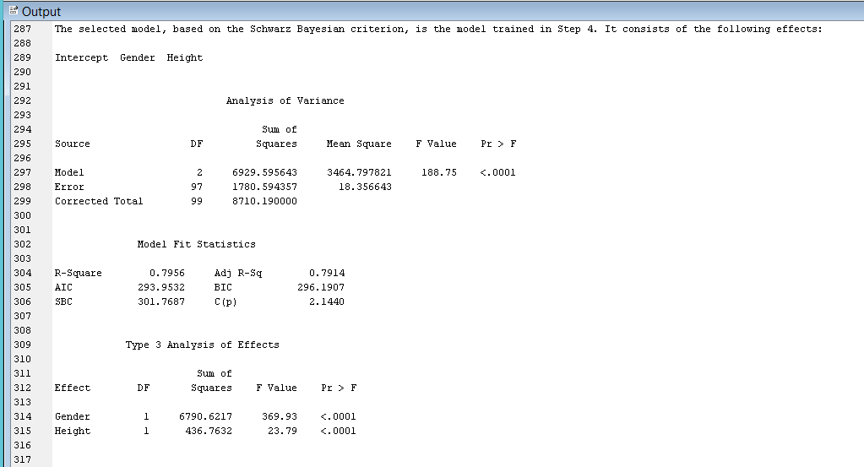
Fit statistics
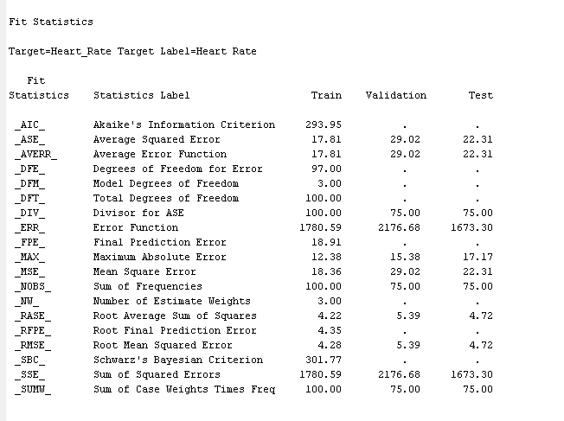
Assessment
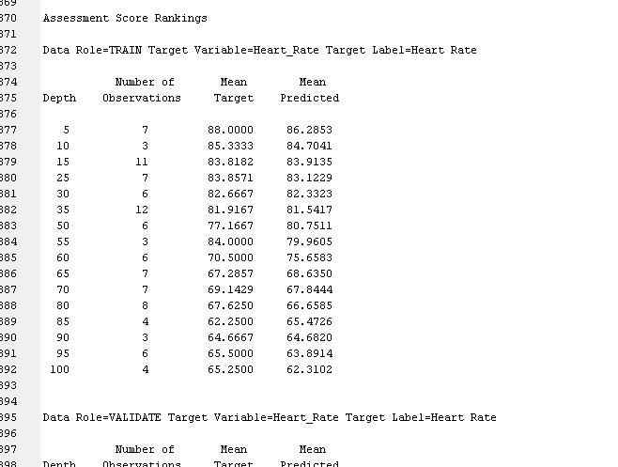

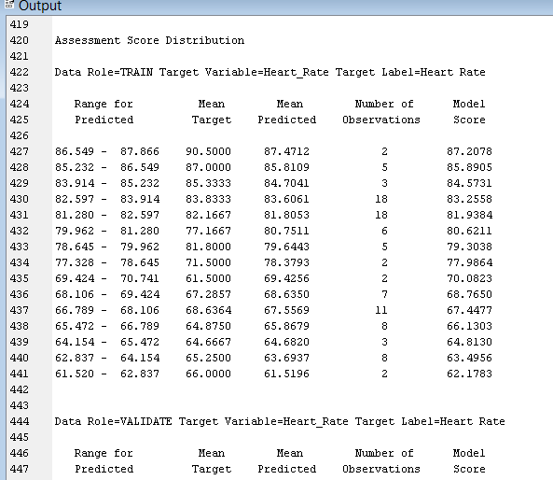
Assessment
The model indicated the role of gender and height in the determination of heart rate

References
Abdolell, M., LeBlanc, M., Stephens, D., & Harrison, R. V. (2002). Binary partitioning for continuous longitudinal data: categorizing a prognostic variable. Statistics in medicine, 21(22), 3395-3409.
Perret-Guillaume, C., Joly, L., & Benetos, A. (2009). Heart rate as a risk factor for cardiovascular disease. Progress in cardiovascular diseases, 52(1), 6-10
WHO (2017). Cardiovascular diseases (CVDs). Available online at https://www.who.int/news-room/fact-sheets/detail/cardiovascular-diseases-(cvds)

